Приложение 7 к Протоколу заочного голосования Организационного комитета Международной олимпиады Ассоциации «Глобальные университеты» для абитуриентов магистратуры и аспирантуры от 20.06.2023 № 1-з
Структура научного профиля (портфолио) потенциальных научных руководителей участников трека аспирантуры Международной олимпиады Ассоциации «Глобальные университеты» для абитуриентов магистратуры и аспирантуры.
University | Federal State Autonomous Educational Institution of Higher Education I.M. Sechenov First Moscow State Medical University of the Ministry of Health of the Russian Federation (Sechenov University)
Level of English proficiency | Upper intermediate
Educational program and field of the educational program for which the applicant will be accepted | 31.06.01 Clinical medicine (educational program)  3.1.7 Dentistry, oral surgery and medicine (field of the educational program)
List of research projects of the potential supervisor (participation/leadership) | The use of CBCT for the diagnosis of vertical root fractures.  Dentin hypersensitivity management  The effect of oral foams on salivary pH changes after consumption of acidic drinks  Knowledge, attitudes, and practice of Russian dentists towards the use of cone-beam computed tomography.
List of the topics offered for the prospective scientific research | The comparison of the effectiveness of desensitizing toothpastes/oral rinses  Root canal morphology evaluated by cone-beam computed tomography in a Russian population  The effect of toothpastes containing inulin in complex treatment of inflammatory periodontal diseases.  The effect of kinesiotaping in the treatment of temporomandibular disorders.  The accuracy of objective methods for the assessment o tooth color.  Dental status and oral care in adult patients with cerebral palsy.  The accuracy of cone-beam CT for the assessment of root canal anatomy and root canal length measurement before endodontic treatment.
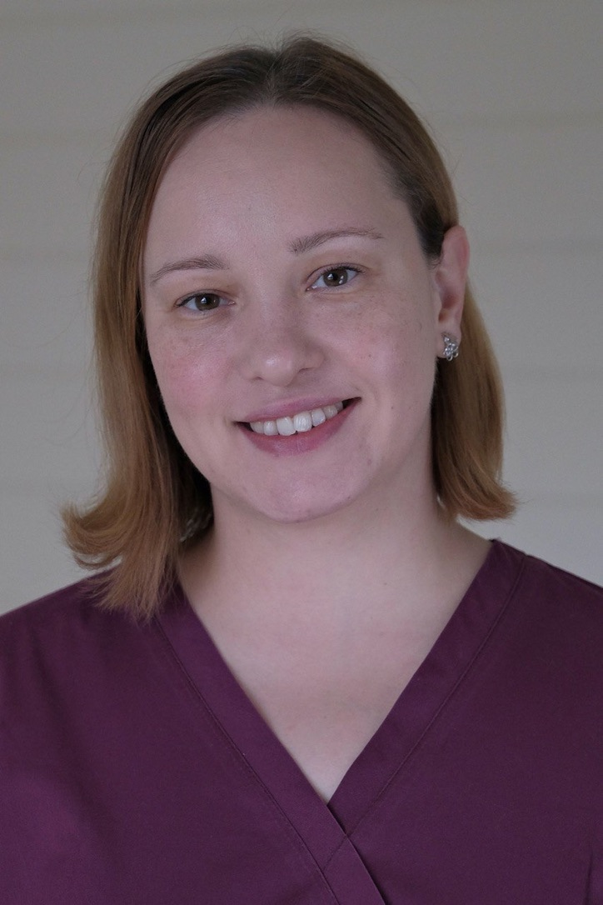  Research supervisor:  Nina E. Novozhilova,  Candidate of Science (Sechenov University) | 3.02 Clinical medicine FY Dentistry, oral surgery and medicine
 | Supervisor’s research interests the accuracy of CBCT for the diagnosis of endodontic complications; the use of toothpastes for dentin hypersensitivity treatment.
Research highlights
None
Supervisor’s specific requirements:
Dental examination (clinical examination, investigations and imaging).
Caries and non-carious lesions of hard tooth tissues.
Pulp pathology.
Periodontology.
Oral mucosa diseases.
Basic statistics.
Supervisor’s main publications (20 publications in the last 5 years):
Makeeva, I.M., Byakova, S.F., Novozhilova, N.E., Adzhieva, E.K., Golubeva, G.I., Grachev, V.I., Kasatkina, I.V. Detection of artificially induced vertical root fractures of different widths by cone beam computed tomography in vitro and in vivo (2016) International Endodontic Journal, 49 (10), pp. 980-989.
Byakova, S.F., Novozhilova, N.E., Makeeva, I.M., Grachev, V.I., Kasatkina, I.V. The accuracy of CBCT for the detection and diagnosis of vertical root fractures in vivo (2019) International Endodontic Journal, 52 (9), pp. 1255-1263.
Byakova, S.F., Novozhilova, N.E., Makeeva, I.M., Grachev, V.I., Kasatkina, I.V. The detection of vertical root fractures in post-core restored teeth ith cone-beam CT: In vivo and ex vivo (2019) Dentomaxillofacial Radiology, 48 (6), art. no. 20180327
Babina, K., Polyakova, M., Sokhova, I., Doroshina, V., Arakelyan, M., Novozhilova, N. The effect of finishing and polishing sequences on the surface roughness of three different nanocomposites and composite/enamel and composite/cementum interfaces (2020) Nanomaterials, 10 (7), art. no. 1339, pp. 1-14.
Polyakova, M.A., Arakelyan, M.G., Babina, K.S., Margaryan, E.G., Sokhova, I.A., Doroshina, V.Y., Novozhilova, N.E. Qualitative and quantitative assessment of remineralizing effect of prophylactic toothpaste promoting brushite formation: A randomized clinical trial (2020) Journal of International Society of Preventive and Community Dentistry, 10 (3), pp. 359-367.
 | Results of intellectual activity N/A

