Приложение 7 к Протоколу заочного голосования Организационного комитета Международной олимпиады Ассоциации «Глобальные университеты» для абитуриентов магистратуры и аспирантуры от 20.06.2023 № 1-з
Структура научного профиля (портфолио) потенциальных научных руководителей участников трека аспирантуры Международной олимпиады Ассоциации «Глобальные университеты» для абитуриентов магистратуры и аспирантуры.
University | I.M. Sechenov First Moscow State Medical University (Sechenov University)
Level of English proficiency | B2 , Upper Intermediate
Educational program and field of the educational program for which the applicant will be accepted | MEDICAL AND HEALTH SCIENCES  3.01Basic medical research  (AY) ANATOMY & MORPHOLOGY
List of research projects of the potential supervisor (participation/leadership) | Neuroanatomy of brain structures. Anatomical, physiological and clinical perspectives for studying the drainage (glymphatic) system of the brain in the context of neurodegenerative diseases Blood supply to adjacent arterial zones of the brain and microanastomoses of vessels  Respiratory medicine  Anatomical approaches in modern neurosurgery;  Morphology of the volume of the ovaries, stroma and ovarian vessels in the ovarian reserve in the menopausal and postmenopausal periods  Morphological age markers of connective tissue dysplasia
List of the topics offered for the prospective scientific research | Study of macro-micrometric (quantitative) structural components of the ovary in elderly and senile ages; mathematical modeling of age-related and pathological processes;  Variant anatomy of the musculoskeletal system due to age-related changes (vertebral column, pelvic bones, knee joint, bones of the upper limbs, upper and lower jaws);  Study of biomechanical and morphological features of the ligamentous apparatus of joints in the age aspect;  Craniometry and clinical anatomy;  Lymphoid structures of the respiratory organs under low-dose radiation and chemical exposure
Research supervisor:  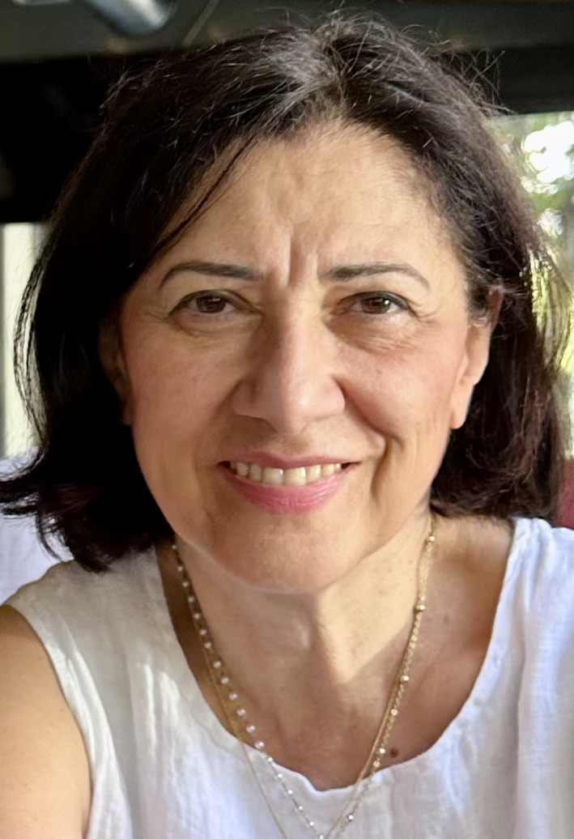  Oganesyan Marine Valikovna,  Candidate of Sciences, Associate Professor of the Department of Human Anatomy and Histology, Sechenov University | Medical Sciences and Public Health  3.01 Fundamental medicine  AY Anatomy and morphology  3.02 Clinical medicine LG Gerontology
Supervisor’s research interests
Research of low-dose radiation-chemical effects on the respiratory system; macro-micrometric (quantitative) structural components of the ovary in elderly and senile ages; morphology of connective tissue structures of the spine, bones of the lower limb in the age aspect; mathematical modeling of age-related and pathological processes
Research highlights (при наличии)
Collection of clinical material;
fixation and preparation of microslides using modern histological stains;
work on modern microscopic equipment;
study of MRI, CT images;
morphometry,
mathematical data processing, publication of research results

Supervisor’s specific requirements:
. master methods of studying macro- and micropreparations
. be able to use methods of statistical data processing
. use bibliography, be able to write scientific articles, speak at conferences
. have already published research papers in a related field
Supervisor’s main publications (33):
- Amygdala: Neuroanatomical and Morphophysiological Features in Terms of Neurological and Neurodegenerative Diseases V.N. Nikolenko, M.V. Oganesyan, N.A. Rizaeva,VA. … M.Y. Sinelnikov July 2020 Brain Sciences 10 (8):502 DOI: 10.3390/brainsci10080502
- Current Drug Targets for Gut Microbiota Biocorrection during the SARS-CoV-2 Pandemic: A Systematic Review. M. Sankova, V.N. Nikolenko, M.V. Oganesyan… M.E. Sinelnikov. April 2022 Current Drug Targets 23(11) DOI: 10.2174/1389450123666220418094853
- Current Understanding of Central Nervous System Drainage Systems: Implications in the Context of Neurodegenerative Diseases V.N. Nikolenko, M.V. Oganesyan…G. Aliev Nov 2019 Current Neuropharmacology 17(11) DOI: 10.2174/1570159X17666191113103850
- Nikolenko VN, Rizaeva NA, Beeraka NM, Oganesyan MV, Kudryashova VA, Dubovets AA, Borminskaya ID, Bulygin KV, Sinelnikov MY, Aliev G. The mystery of claustral neural circuits and recent updates on its role in neurodegenerative pathology. Behav Brain Funct. 2021 Jul 7;17(1):8. doi: 10.1186/s12993-021-00181-1. PMID: 34233707; PMCID: PMC8261917
- Recent investigations on the functional role of cerebellar neural networks in motor functions & nonmotor functions - neurodegeneration. N.M. Beeraka, Nikolenko V.N., Zakirov F.KH., Oganesyan M. V.,…and Sinelnikov M.Ye. March 2022 Current Neuropharmacology 20(10) DOI: 10.2174/1570159X20666220310121441
- Age pathognomic indicators of Injury predisposition as a basis for public health preservation during physical activity. Sankova M., Nikoleno V., Oganesyan M., Vovkogon A., Chirkova E., Sinelnikov M. Int. J. Environ. Res. Public Health 2021, 18(4), 1989; doi:10.3390/ijerph18041989
- Sankova M.V., Nikolenko V.N., Oganesyan M.V.,
Bakhmet A.A., Gavryushova L.V., Sankov S.V.,
and Sinelnikov M.Y. Current Drug Targets for Gut
Microbiota Biocorrection during the SARS-CoV-2Pandemic:
A Systematic Review, Current Drug Targets 2022; 23 (11)
Doi:10.2174/1389450123666220418094853

Sankova MV, Nikolenko VN, Oganesyan MV,
Vovkogon AD, Gadzhiakhmedova AN, Zharikova TS,
Zharikov YO Identifying sex-specific injury predictors
as a key factor in maintaining optimal physical activity
levels.2023 World Journal of Orthopaedics 14(3):146-154
DOI: 10.5312/wjo.v14.i3.146
Results of intellectual activity
Co-author of teaching manuals on different topics of human anatomy, multilingual atlas
Curator of many student research works^
- . Nikolenko V.N., Oganesyan M.V., Yakhno N.N., Orlov E.A., Porubayeva E.E., Popova E.Yu. The brain’sglymphatic system:physiological anatomy and clinical perspectives. Neurology, Neuropsychiatry, Psychosomatics. 2018;10(4):94-100. (In Russ.) https://doi.org/10.14412/2074-2711-2018-4-94-100
- . Dissection course in anatomy as stimulus to independent research and to a real step into medicine/Nikolenko, V., Oganesyan, M., Zakirov, F., (...), Rizaeva N., Valiullina P. // Journal of Morphological Sciences - 2019. 36 (2), с. 63-66. https://doi.org/ 10.1055/s-0039-1685222
- . Nikolenko V.N., Rizaeva N.A., Oganesyan M.V., Kudryashova V.A., Golyshkina M.S., Pavlyuk P.A., Unanyan A.L., Gevorgyan M.M., Priputnevich T.V. Tubal infertility: medical, social and psychological aspects of the problem/Obstetrics and gynecology-2020 (11), 213-224. doi: 10.1856/aig.2020.11.213-224
- . Golyshkina M.S., Gevorgyan M.N., Nikolenko V.N., Oganesyan M.V., Pavlyuk P.A., Rizaeva N.A., Unanyan A.L. Female infertility as a factor of emotional disorder: the importance of psychotherapy in the treatment of infertility. Neurology, Neuropsychiatry, Psychosomatics. 2021;13(2):97-103. (In Russ.)https://doi.org/10.14412/2074-2711-2021-2-97-103
. Nikolenko VN, Oganesyan MV, Rizaeva NA, GevorgyanMM. Morphology of the stroma and ovarian vessels in ovarian reserve, in the climacteric and postmenopausal periods / V. G. Koveshnikov Morphological Almanac. 2020; 4:94-8.
. Lukyanchikov VA, Orlov EA, Oganesian MV, Gordeeva AA, Pavliv MP. Anatomical bases of brain revascularization: choosing an extra-intracranial bypass option. Zhurnal Voprosy Neirokhirurgii Imeni N.N. Burdenko. 2021;85(6):120-126.
https://doi.org/10.17116/neiro202185061120
. Dmitriev I, Oganesyan M, Popova A, Orlov E, Sinelnikov M, Zharikov Y. Anatomical basis for pancreas transplantation via isolated splenic artery perfusion: A literature review. World J Clin Cases 2022; 10(35): 12844-12853 [PMID: 36569006 DOI: 10.12998/wjcc.v10.i35.12844]
. V. N. Nikolenko, N. A. Rizaeva, M. V. Oganesyan, K. A. Vekhova, N. A. F. Alyautdinova, S. I. Balan, T. A. Karashaeva, A. A. Bolotskaya Brain commissures and related pathologies, 2022. 14(6):73-79 Neurology neuropsychiatry Psychosomatics https://doi.org/10.14412/2074-2711-2022-6-73-79 Online ISSN: 2310-1342 Print ISSN: 2074-2711
. Nikolenko V.N., Kudryavtseva V.A., Oganesyan M.V., Rizaeva N.A., Bolotskaya A.A., Zharikova T.S. MODERN VIEWS ABOUT THE ANATOMY OF THE DANGEROUS TRIANGLE OF THE FACE. Morphological statements. 2023;31(3):798 https://doi.org/10.20340/mv-mn.2023.31(3).798 Nikolenko V.N., Kudryavtseva V.A., Oganesyan M.V., Rizaeva N.A., Bolotskaya A.A., . Zharikova T.S. The modern data about the anatomy of a dangerous triangle of the face. Morphological newsletter. 2023;31(3) doi:798 10.20340/mv-mn.2023.31(3).798

