Приложение 7 к Протоколу заочного голосования Организационного комитета Международной олимпиады Ассоциации «Глобальные университеты» для абитуриентов магистратуры и аспирантуры от 20.06.2023 № 1-з
Структура научного профиля (портфолио) потенциальных научных руководителей участников трека аспирантуры Международной олимпиады Ассоциации «Глобальные университеты» для абитуриентов магистратуры и аспирантуры.
На русском языке:

На английском языке:

University | Sechenov University
Level of English proficiency | Upper Intermediate
Educational program and field of the educational program for which the applicant will be accepted | 31.06.01 Clinical medicine (educational program)  3.1.17 Psychiatry and Narcology (field of the educational program)
List of research projects of the potential supervisor (participation/leadership) | Search for biological markers of depressive and anxiety disorders  Affective disorders in late life  Cognitive function in depression  Remote monitoring of remission in schizophrenia  Post-Covid mental disorders
List of the topics offered for the prospective scientific research | 1. Psychopharmacotherapy of depressive disorders in patients with schizophrenia.  2. Mental disorders developing after COVID-19: follow-up observation  3. First depressive episode: typology, differentiated treatment approaches  4. Pharmacotherapy of recurrent depression: predictors of relapse  5. Remission in panic disorders  6. Remote monitoring of remission in schizophrenia spectrum disorders  7. Recurrence of depression
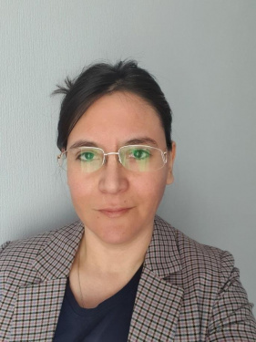  Research supervisor:  Yuliya G Tikhonova,  Doctor of Science (Sechenov University) | 3.02 Clinical medicine. Psychiatry
Supervisor’s research interests
Research the psychopathology of affective disorders, the psychopathological structure and relationships with various factors. Development and optimization of personalized treatment for affective disorders. Development of monitoring of remission in schizophrenia. Scientific search for biomarkers of depressive and anxiety disorders (pharmacogenetics, epigenetic factors, exosomes)
 | Research highlights (при наличии)
Supervisor’s specific requirements:
residency in psychiatry
Supervisor’s main publications - 9
Ivanets, N.N., Kinkul’kina, M.A., Tikhonova, Y.G. et al. Unipolar Depressive Disorders: A Gender-Based Comparative Analysis. Neurosci Behav Physi 52, 505–510 (2022).
Tarasov VV, Ivanets NN, Svistunov AA, Chubarev VN, Kinkulkina MA, Tikhonova YG, Syzrantsev NS, Chubarev IV, Muresanu C, Somasundaram SG, Kirkland CE, Aliev G. Biological Mechanisms of Atypical and Melancholic Major Depressive Disorder. Curr Pharm Des. 2021 Oct 5;27(31):3399-3412
Ivanets NN, Svistunov AA, Chubarev VN, Kinkulkina MA, Tikhonova YG, Syzrantsev NS, Sologova SS, Ignatyeva NV, Mutig K, Tarasov VV. Can Molecular Biology Propose Reliable Biomarkers for Diagnosing Major Depression? Curr Pharm Des. 2021;27(2):305-318.
Results of intellectual activity (при наличии)
Unipolar depressive disorders: clinical picture, differentiated approaches to therapy. Kinkulkina M.A., Ivanets N.N., Tikhonova Yu.G. Monograph. 2020
Depression during antiviral therapy of chronic hepatitis C. Diagnosis and differentiated treatment. Ivanets N.N., Kinkulkina M.A., Avdeeva T.I., Tikhonova Yu.G., Volkov A.V., Morozov D.I. Monograph, 2015

