Приложение 7 к Протоколу заочного голосования Организационного комитета Международной олимпиады Ассоциации «Глобальные университеты» для абитуриентов магистратуры и аспирантуры от 20.06.2023 № 1-з
Структура научного профиля (портфолио) потенциальных научных руководителей участников трека аспирантуры Международной олимпиады Ассоциации «Глобальные университеты» для абитуриентов магистратуры и аспирантуры.

На английском языке:
University | Sechenov University
Level of English proficiency | B2
Educational program and field of the educational program for which the applicant will be accepted | 3.02 Clinical medicine (educational program)  3.02 WE, 3.02 DS (field of the educational program)  3.1.29. Pulmonology
List of research projects of the potential supervisor (participation+leadership) | - Assessment of work of breathing and ventilator-associated lung injury during controlled and assisted ventilation in patients with acute respiratory failure  - Assessment of work of breathing and ventilator-associated lung injury during non-invasive ventilation in patients with acute respiratory failure  - Assessment of diaphragmatic dysfunction in patients with acute respiratory failure  - Electrical impedance tomography of the lungs in patients with acute respiratory failure  - Selecting the optimal PEEP level in the operating room
List of the topics offered for the prospective scientific research | - Assessment of diaphragmatic dysfunction in acute and chronic respiratory failure  - Biomechanics of breathing in patients with alveolar proteinosis during total lung lavage  - Assessment of alveolar recruitability during non-invasive ventilation  - Assessment of patient self-inflicted lung injury during non-invasive ventilation  - Non-invasive assessment of respiratory biomechanics in patients undergoing non-invasive ventilation  - Volumetric capnography to select optimal respiratory support parameters  - Comprehensive monitoring of carbon dioxide excretion in chronic respiratory failure
Research supervisor:  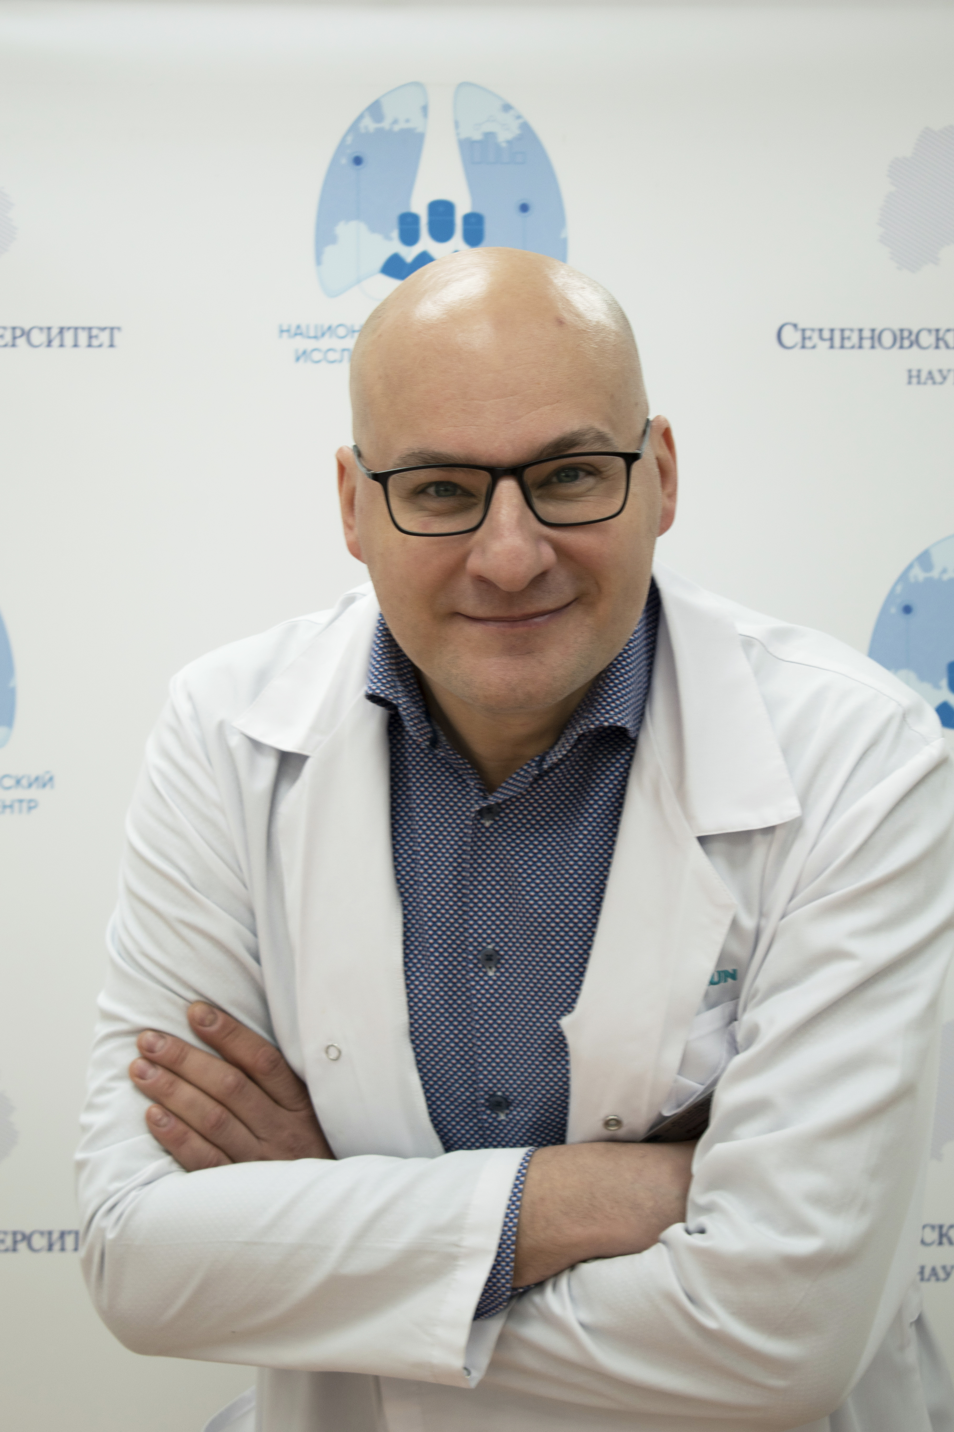  Andrey I. Yaroshetskiy  PhD, ScD (Sechenov University | 3.02 WE, 3.02 DS (field of the educational program)
Supervisor’s research interests
Respiratory support
Pathophysiology of respiratory failure
Research highlights:
study of the physiology of breathing in respiratory failure using physiological monitoring (airway pressure, transpulmonary pressure, esophageal pressure, intra-abdominal pressure, gastric pressure, pressure-volume and flow-volume loops, ultrasound examination of the diaphragm, electrical impedance tomography)
Supervisor’s specific requirements:
- postgraduate education in anesthesiology and resuscitation
- knowledge of methods for assessing respiratory physiology in respiratory failure (measurement of pressure in the respiratory tract, transpulmonary pressure, esophageal pressure, intra-abdominal pressure, the ability to build and evaluate “pressure-volume” and “flow-volume” loops, ultrasound examination of the diaphragm, electrical impedance tomography)
Supervisor’s main publications
Total number of publications in journals indexed by Web of Science, Scopus, RSCI over the past 5 years - 25
- Yaroshetskiy AI, Merzhoeva ZM, Tsareva NA, et al. Breathing pattern, accessory respiratory muscles work, and gas exchange evaluation for prediction of NIV failure in moderate-to-severe COVID-19-associated ARDS after deterioration of respiratory failure outside ICU: the COVID-NIV observational study. BMC Anesthesiol. 2022; 22: 307. doi: 10.1186/s12871-022-01847-7
- Yaroshetskiy AI, Avdeev SN, Politov ME, et al. Potential for the lung recruitment and the risk of lung overdistension during 21 days of mechanical ventilation in patients with COVID-19 after noninvasive ventilation failure: the COVID-VENT observational trial. BMC Anesthesiol. 2022 Mar 4;22(1):59. doi: 10.1186/s12871-022-01600-0.
- Yaroshetskiy AI, Nuralieva GS, Krasnoshchekova AP, Avdeev SN. Higher PEEP in intubated COVID-19-associated ARDS patients? We are not sure. Crit Care 2022; 26: 325. doi : 10.1186/s13054-022-04207-6
- Avdeev, S.N., Yaroshetskiy, A.I., Nuralieva, G.S. et al. High‑flow nasal cannula is not more effective than conventional oxygen therapy for acute exacerbation of COPD with mild hypercapnia: we are not sure. Crit Care 26, 156 (2022). https://doi.org/10.1186/s13054-022-04022-z
- Mandel IA, Podoksenov YK, Mikheev SL, Suhodolo IV, Svirko YS, Shipulin VM, Ivanova AV, Yavorovskiy AG, Yaroshetskiy AI. Endothelial Function and Hypoxic–Hyperoxic Preconditioning in Coronary Surgery with a Cardiopulmonary Bypass: Randomized Clinical Trial. Biomedicines. 2023; 11(4):1044. https://doi.org/10.3390/biomedicines11041044
Results of intellectual activity
Not Applicable

