Приложение 7 к Протоколу заочного голосования Организационного комитета Международной олимпиады Ассоциации «Глобальные университеты» для абитуриентов магистратуры и аспирантуры от 20.06.2023 № 1-з
Структура научного профиля (портфолио) потенциальных научных руководителей участников трека аспирантуры Международной олимпиады Ассоциации «Глобальные университеты» для абитуриентов магистратуры и аспирантуры.
University | Sechenov University
Level of English proficiency | В2
Educational program and field of the educational program for which the applicant will be accepted | 32.06.01 Medical and preventative care (educational program)  3.2.3. Public health, organization and sociology of healthcare, medical and social expertise (field of the educational program)
List of research projects of the potential supervisor (participation/leadership) | -
List of the topics offered for the prospective scientific research | - Awareness and attitude of the population towards vaccination  - The lifestyle of students and its determinants  - Attitude of the population towards the use of digital technologies in healthcare  - Occupational risk factors that determine the health status of medical workers  - Quality of life of the population and its determinants  - Emotional burnout of medical workers  - Quality of life of patients
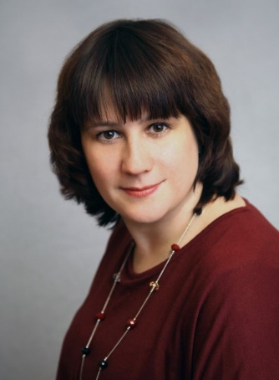  Research supervisor:  Maria S. Mikerova,  Candidate of Medical Science (Sechenov Moscow Medical Academy) | Public, Environmental & Occupational Health
Supervisor’s research interests
Health of certain population groups, factors influencing public health, lifestyle of the population
Research highlights (при наличии)
-
Supervisor’s specific requirements:
Presence of a research base, experience in planning and conducting scientific research and publishing results, knowledge of statistical analysis methods, high skills in use the SPSS program
Supervisor’s main publications
12 publications in journals indexed by Web of Science, Scopus, RSCI over the last 5 years
- Reshetnikov V.A., Ekkert N.V., Capasso L., Arsentyev E.V., Mikerova M.S., Yukushina I.I. The history of public healthcare in Russia. Medicina Historica 2019; Vol. 3, N. 1: 16-24.
- Reshetnikov V.A., Sergeev A.R., Vesić Z., Golubeva A.P., Bolevich S.B., Jevtić A., Mikerova, M.S. Effects of social interactions on psychoactive substance use by medical students. / Vojnosanitetski Pregled. – 2020. – 77(6). – pp. 661–662. https://doi.org/10.2298/VSP200321047R.
- Reshetnikov A. V., Prisyazhnaya N. V., Reshetnikov V. A., Efimov I. A., Mikerova M. S., Bocharova M. O. Perception of healthy lifestyle among students of medical schools. / Serbian Journal of Experimental and Clinical Research. –2020. – 21(1). – pp. 67–74. DOI: 10.2478/sjecr-2020-0016.
- Reshetnikov V., Mitrokhin O., Belova E., Mikhailovsky V., Mikerova M., Alsaegh A., Yakushina I., Royuk V. Indoor Environmental Quality in Dwellings and Lifestyle Behaviors during the COVID-19 Pandemic: Russian Perspective./ International Journal of Environmental Research and Public Health.–2021.–18(11).–p.5975; https://doi.org/10.3390/ijerph18115975.
- Nikolic Turnic T., Mijailovic S., Nikolic M., Dimitrijevic J., Milovanovic O., Djordjevic K., Folic M., Tasic L., Reshetnikov V., Mikerova M., Milovanovic D., Jakovljevic V. Attitudes and Opinions of Biomedical Students: Digital Education Questionnaire./ Sustainability.–2022. – 14. – 9751. https://doi.org/10.3390/su14159751.
- Nikolic Turnic T., Vasiljevic I., Stanic M., Jakovljevic B., Mikerova M., Ekkert N., Reshetnikov V., Jakovljevic V. Post-COVID-19 Status and Its Physical, Nutritional, Psychological, and Social Effects in Working-Age Adults – A Prospective Questionnaire Study. /Journal of Clinical Medicine. – 2022. – 11. – 6668. https://doi.org/10.3390/jcm11226668.
Results of intellectual activity (при наличии)
-

