Приложение 7 к Протоколу заочного голосования Организационного комитета Международной олимпиады Ассоциации «Глобальные университеты» для абитуриентов магистратуры и аспирантуры от 20.06.2023 № 1-з
Структура научного профиля (портфолио) потенциальных научных руководителей участников трека аспирантуры Международной олимпиады Ассоциации «Глобальные университеты» для абитуриентов магистратуры и аспирантуры.
University | Federal State Autonomous Educational Institution of Higher Education I.M. Sechenov First Moscow State Medical University of the Ministry of Health of the Russian Federation (Sechenov University)
Level of English proficiency | Advanced (fluent)
Educational program and field of the educational program for which the applicant will be accepted | 31.06.01 Clinical medicine (educational program)
List of research projects of the potential supervisor (participation/leadership) | - The contribution of the microbiome to the defeat of the gastrointestinal tract  - Artificial liver function support systems in patients  - Diagnostic accuracy of liver fibrosis and steatosis assessment methods  - Efficacy and safety of drug therapy for chronic liver and gastrointestinal diseases
List of the topics offered for the prospective scientific research | 1. Complications of liver cirrhosis  2. Microbiota and gastrointestinal diseases  3. Alcoholic liver disease  4. Metabolic syndrome  5. Metabolic syndrome associated with liver diseases  6. Evidence-based medicine: systematic review and meta-analysis  7. Diagnostic accuracy of non-invasive diagnostic methods
Ф 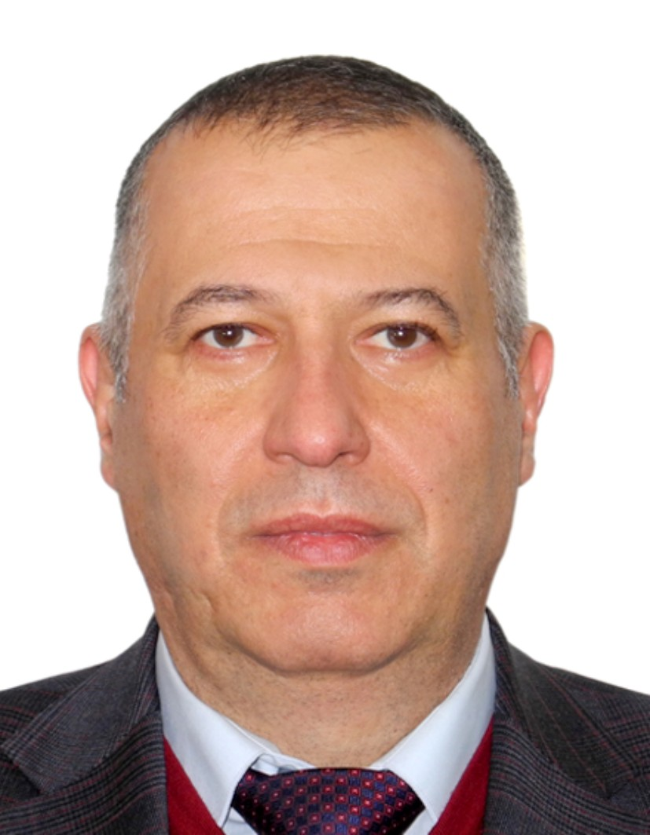 ото  Research supervisor:  Professor Chavdar Pavlov, MD, Ph.D., MScD  I.M. Sechenov First Moscow State Medical University  (Sechenov University)  Head of the Department of Therapy, Head of the Center for Evidence-based Medicine, Deputy Director for Science Institute of Clinical Medicine 'Sechenov' First Moscow State Medical University (http://www.cep.ru/mma.shtml).  Clinical trial investigator in more than 20 trials. | CLINICAL MEDICINE  GASTROENTEROLOGY & HEPATOLOGY
Supervisor’s research interests
1. Chronic liver diseases
2. Chronic gastrointestinal diseases
3. Gut microbiome
4. Methods for diagnosing gastrointestinal diseases
Research highlights (при наличии)
Study by an international team of scientists and clinicians
Supervisor’s specific requirements:
Knowledge
• English
• Methods of evidence-based medicine
Supervisor’s main publications
Pavlov, Ch S.
Scopus h-индекс 14
https://www.scopus.com/authid/detail.uri?authorId=57196355076

Liver support systems for adults with acute-on-chronic liver failure. Martí-Carvajal, A.J., Gluud, C., Gluud, L.L.,Pavlov, C.S. ...Comunián-Carrasco, G., Nicola, S. Cochrane Database of Systematic Reviewsthis link is disabled, 2022, 2022(11), CD015119

Human stem cells for decompensated cirrhosis in adults. Aung, H.H., Aye, S.N., Htet, N.H., ...Kew, S.T., Pavlov, C.S. Cochrane Database of Systematic Reviewsthis link is disabled, 2022, 2022(10), CD015173

Sphincterotomy for people with biliary sphincter of Oddi dysfunction. Naing, C., Aung, H.H., Ni, H., Htet, N.H., Pavlov, C.S. Cochrane Database of Systematic Reviewsthis link is disabled, 2022, 2022(9), CD014944

Liver support systems for adults with acute liver failure. Martí-Carvajal, A.J., Gluud, C., Gluud, L.L., Pavlov, C.S....Comunián-Carrasco, G., Martí-Amarista, C.E. Cochrane Database of Systematic Reviewsthis link is disabled, 2022, 2022(7), CD015059

Antibiotic prophylaxis to prevent spontaneous bacterial peritonitis in people with liver cirrhosis: a network meta-analysis. Komolafe, O., Roberts, D., Freeman, S.C., Pavlov, C.S., Tsochatzis, E., Gurusamy, K.S. Cochrane Database of Systematic Reviews, 2020, 2020(1), CD013125
Results of intellectual activity (при наличии)
- Former Vice-President for Foreign Relations with Russian Scientific Liver Society, Vice-President of the Russian Scientific Society for the Study of Microbioma
- EUMS diploma of fellow in Gastroenterology № 597, 27 October
- 2007 Member of EBGH (European Board of Gastroenterology and Hepatology).
- 2003-Won 3rd Poster Prize with ‘Seronegative chronic hepatitis C: long-term monitoring’ at XII Falk Liver Week, Freiburg (Germany) October 17-19.
- 2006-Boursier de la Societe Nationale Francais de Gastro-Enterologie, Stage- Service d` Hepatologie Hopital Henri Mondor- Creteil- Paris.

