The structure of the scientific profile (portfolio) of potential scientific supervisors of the participants of the International Olympiad of the Association "Global Universities" on the track of postgraduate studies in 2023-2024.
University | ФГАОУ ВО Первый МГМУ им. И.М. Сеченова Минздрава России (Сеченовский Университет)
Level of English language proficiency | B2
The direction of training for which the graduate student will be accepted | Urology and andrology. Clinical medicine
List of research projects of a potential supervisor (participation/guidance) | 1) Reconstructive surgery of the urethra and penis  2) Urolithiasis  3) Male infertility
List of possible research topics | 1) Evaluation of the effectiveness of BMG urethroplasty in patients with recurrent urethral strictures  2) Penile prosthetic surgery for patients with Peyronie's disease
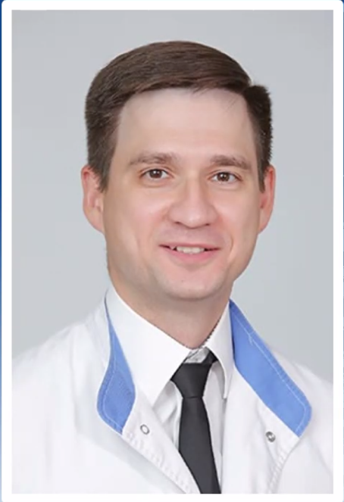  Research supervisor:  Dmitry O. Korolev,  Candidate of Science  (Sechenov University) | 3.02 Clinical medicine. Urology, andrology and nephrology
Supervisor’s research interests (более детальное описание научных интересов):
1) urolithiasis; 2) reconstructive-plastic surgery of the urethra and penis; 3) surgery of urolithiasis; 4) male infertility and erectile dysfunction

Research highlights:
1) multicenter studies
2) work with domestic and international grants
3) prospective study design

Supervisor’s main publications (указать общее количество публикаций в журналах, индексируемых Web of Science, Scopus, RSCI за последние 5 лет, написать до 5 наиболее значимых публикаций с указанием выходных данных): 41 публикация (18 ВАК, 23 Scopus) 4 патента

- Minimally invasive percutaneous nephrolithotomy with SuperPulsed Thulium-fiber laser. Urolithiasis 2021, 49(5), стр. 485–491 doi: 10.1007/s00240-021-01258-2
- Thulium-fiber laser for lithotripsy: first clinical experience in percutaneous nephrolithotomy. orld J Urol. 2020 Dec;38(12):3069-3074. doi: 10.1007/s00345-020-03134-x.Epub 2020 Feb 27.
- Repair of cystocele and apical genital prolapse using 6-strap mesh implant. Urologia. 2020 Aug;87(3):130-136. doi: 10.1177/0391560319890999. Epub 2019 Dec 16.
- Flexible ureteroscopy for lower pole renal stones: novel superpulse thulium (TM) fiber laser lithotripsy. Urologiia. 2020 Dec;(6):89-92.
- The cancer-retina antigen recoverin as a potential biomarker for renal tumors. our Biol. 2016 Jul;37(7):9899-907.doi: 10.1007/s13277-016-4885-5. Epub 2016 Jan 26.
Results of intellectual activity (при наличии)
(Наиболее значимые результаты интеллектуальной деятельности):
Publications: 18 ВАК, 23 Scopus, 4 патента

