Приложение 7 к Протоколу заочного голосования Организационного комитета Международной олимпиады Ассоциации «Глобальные университеты» для абитуриентов магистратуры и аспирантуры от 20.06.2023 № 1-з
Структура научного профиля (портфолио) потенциальных научных руководителей участников трека аспирантуры Международной олимпиады Ассоциации «Глобальные университеты» для абитуриентов магистратуры и аспирантуры.
University | I.M.Sechenov First Moscow State Medical University (Sechenov University)
Level of English proficiency | B1 – Intermediate
Educational program and field of the educational program for which the applicant will be accepted | 3 MEDICAL AND HEALTH SCIENCE  3.02 Clinical medicine  STQ PEDIATRICS
List of research projects of the potential supervisor (participation/leadership) | Research theme "Improvement of methods of diagnostics and control of effectiveness of therapy of chronic liver diseases (CLD) in children" 2022-2024. Project leader  Research theme "Optimization of medical care for children with inflammatory bowel diseases in the conditions of a multidisciplinary pediatric hospital" 2022-2024. Theme Leader
List of the topics offered for the prospective scientific research | List of 7-10 scientific topics, which are offered by the research supervisor for consideration of foreign applicants  (During the course of the Interview the topic may be modified according to specific area of scientific interest of the applicant):  Combination of inflammatory bowel diseases with psoriasis  Peculiarities of diagnostics, course and therapy of autoimmune sclerosing cholangitis in children  Peculiarities of nutritive status and its correction in children with liver cirrhoses  Extraintestinal manifestations of IBD  Celiac disease and autoimmune hepatitis in children  Orphan liver diseases in children: peculiarities of diagnosis and treatment  Role and possibilities of instrumental diagnostics in assessment of transmural inflammation in pediatric IBD
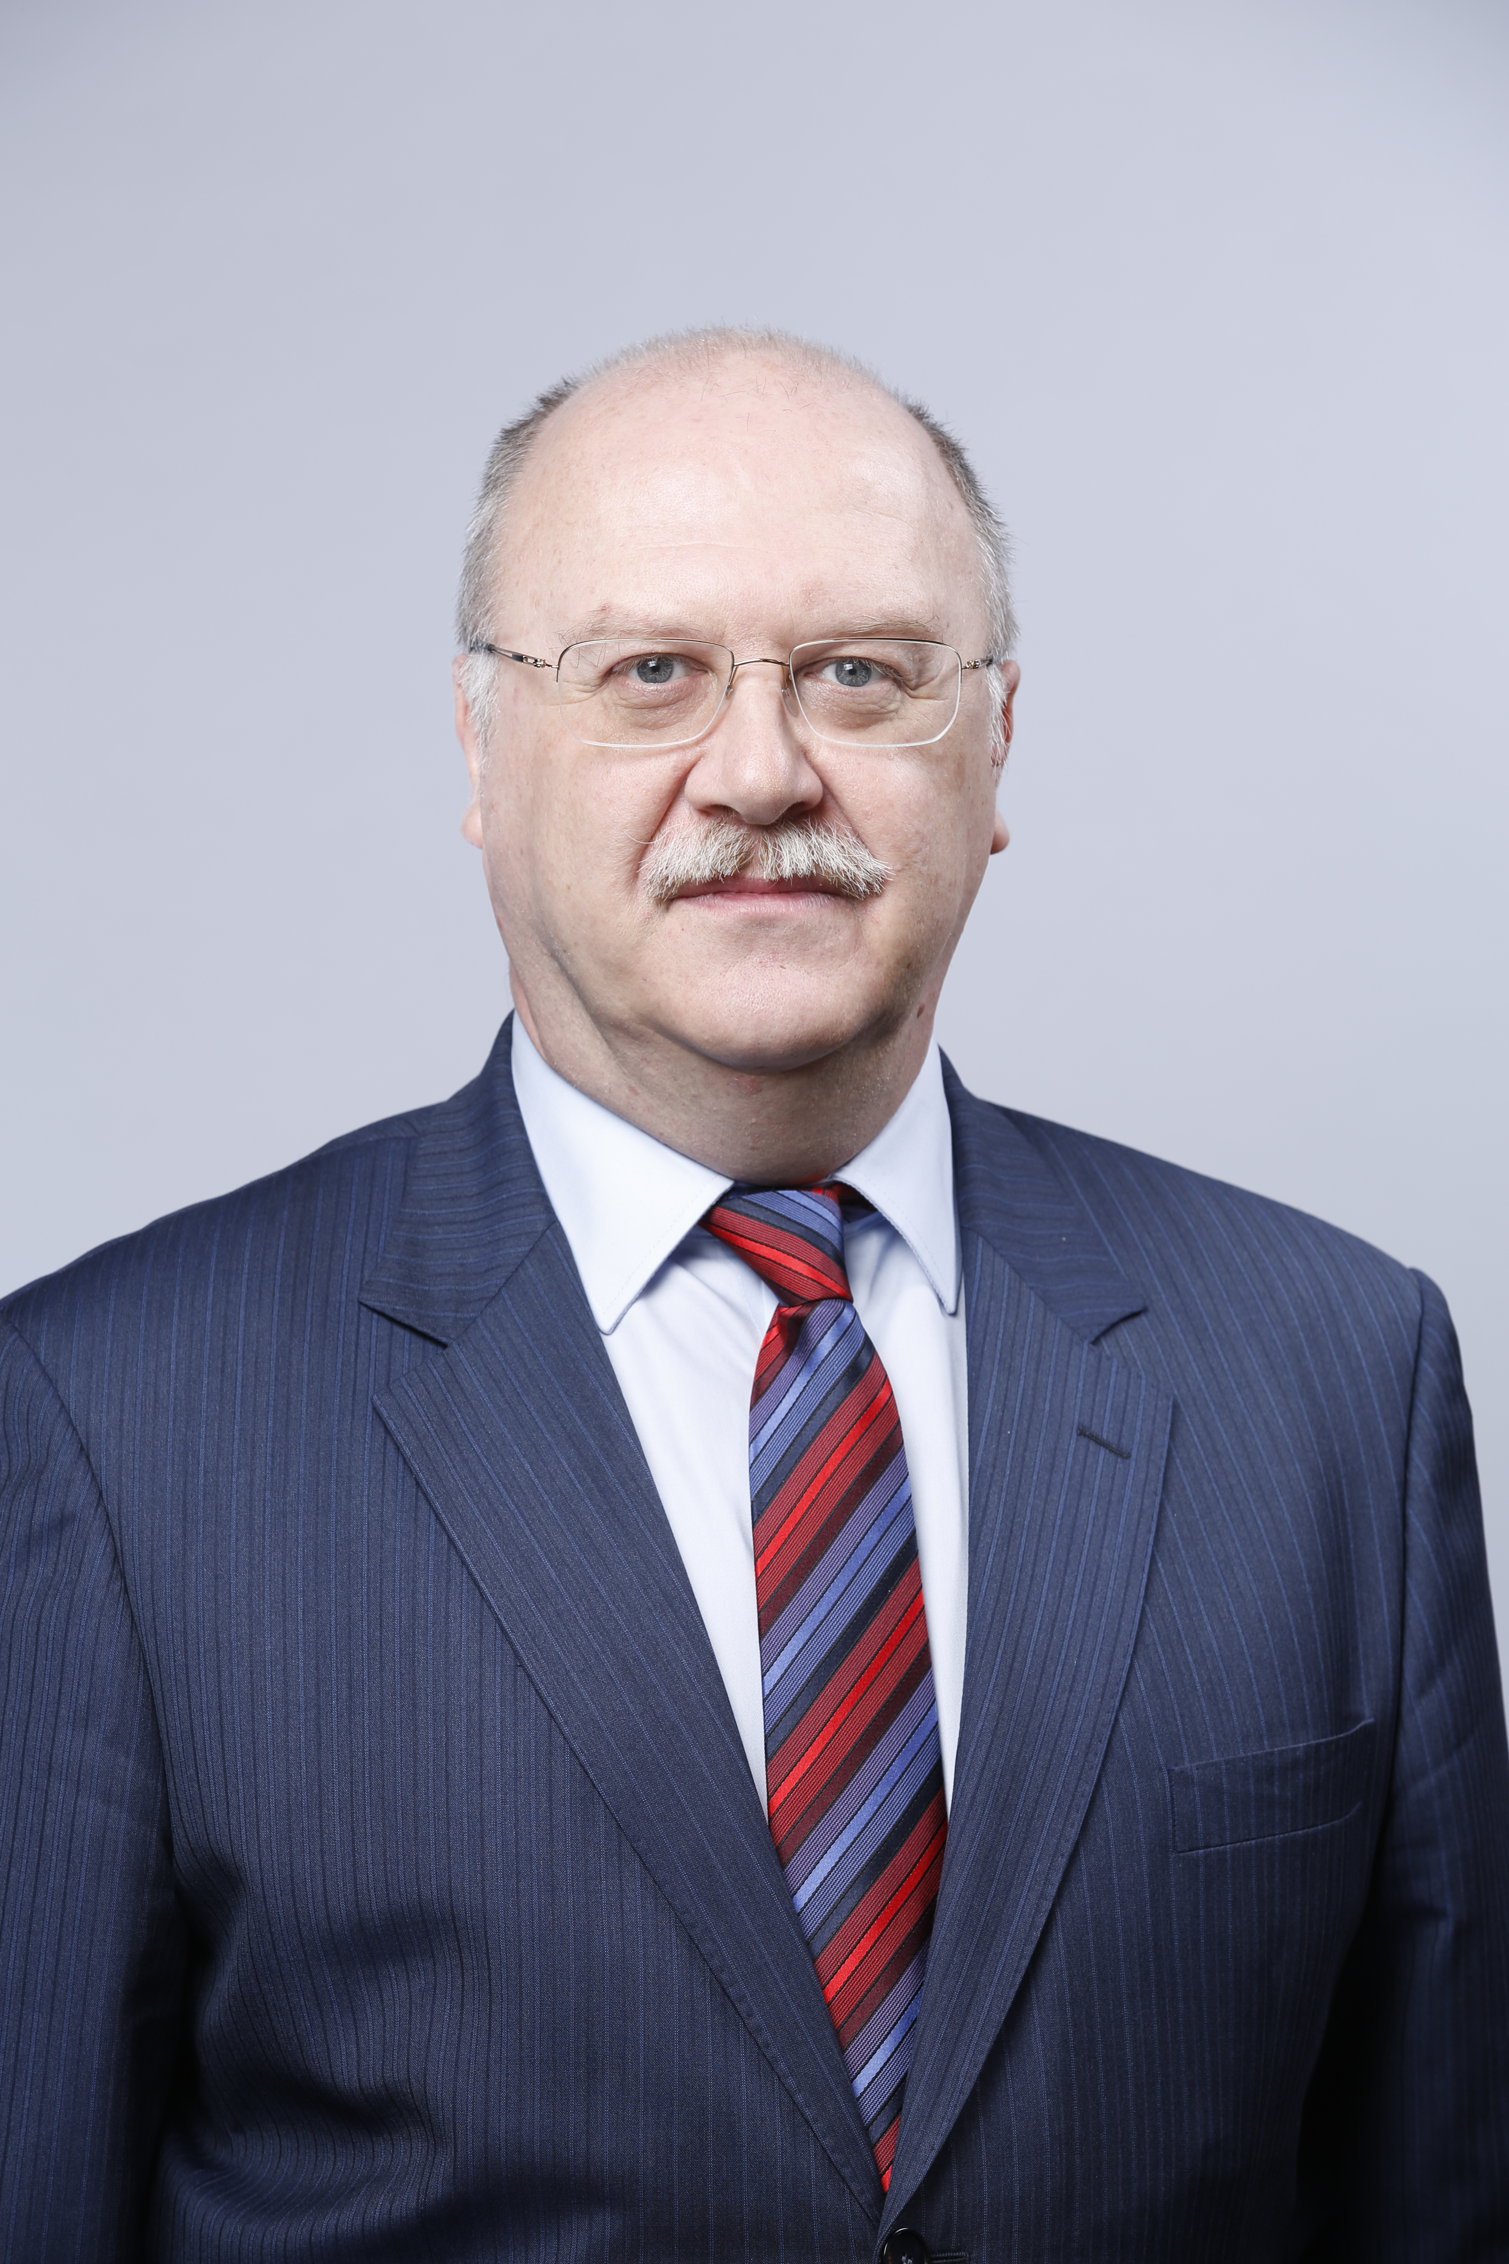Фото  Research supervisor:  Alexander S. Potapov,  MD, DMSci, prof. (Research Institute of Pediatrics, Russian Academy of Medical Sciences) | Заголовок (указывается направление международной карты науки, соответствующее области исследования, карта науки доступна по ссылке)
Supervisor’s research interests
The problem of inflammatory bowel diseases in children (studying the pathogenesis of Crohn's disease and ulcerative colitis on the background of therapy, development and approbation of new diagnostic methods and scoring systems, therapy regimens with the use of biological drugs), chronic liver diseases (autoimmune hepatitis, Wilson's disease), combination of inflammatory bowel diseases with liver pathology and skin lesions..
Research highlights
The main difference of the program on the basis of the gastroenterology department is the presence of a large clinical base of observed patients in the catamnesis (more than 500 patients with IBD, 200 patients with autoimmune hepatitis and about 100 patients with Wilson's disease). All patients are on different regimens of therapy. The center has wide possibilities for endoscopic, clinical and laboratory researches, CT and MRI, various methods of physiotherapy and psychological and pedagogical help to patients and their families are possible. Methods of dietary correction and nutritional support are actively used.
Supervisor’s specific requirements:
Раздел заполняется при наличии требований, предъявляемых к аспиранту (обязательный бэкграунд кандидата/дисциплины, которые он обязательно должен был освоить/ методы, которыми он должен владеть/ уметь пользоваться каким-то определённым ПО и др.)
Supervisor’s main publications
Total number of publications in journals indexed by Web of Science, Scopus, over the last 5 years – 25.
Usoltseva Olga V., Surkov Andrey N., Movsisyan Goar B., Potapov Alexander S., Kulebina Elena A., Kulikov Кirill A., Chernikov Vladislav V. Correlation of Inflammatory Bowel Diseases with Liver Involvement Severity in Autoimmune Hepatobiliary Pathology: Cross-Sectional Study. Voprosy sovremennoi pediatrii — Current Pediatrics. 2022;21(2):105–112. (In Russ). doi: https://doi.org/10.15690/pf.v19i2.2407

Body composition assessment in patients with inflamatory bowel disease
Makarova S.G., Popova I.Yu., Surkov A.N., Potapov A.S., Yasakov D.S., Gordeeva I.G., Anushenko A.O.
Journal of Pediatric Gastroenterology and Nutrition. 2022. Т. 74. № S2. С. 564. DOI: 10.1097/MPG.0000000000003446

Therapeutic drug monitoring of adalimumab in inflammatory bowel disease in children Illarionov A.S., Radygina T.V., Potapov A.S., Fisenko A.P., Kuptsova D.G., Petrichuk S.V., Surkov A.N., Vershinina M.G. PEDIATRIC NUTRITION 2021. Т. 19. № 3. С. 14-25. DOI: 10.20953/1727-5784-2021-3-14-25

Diagnostic value of platelet count and platelet indices in assessing inflammatory bowel disease activity in children Semikina E.L., Tsvetkova V.S., Potapov A.S., Fisenko A.P, Kopyl'tsova E.A, Akulova S.S., Surkov A.N., Lokhmatov M.M., Budkina T.N., Vershinina M.G. PEDIATRIC NUTRITION 2021. Т. 19. № 3. С. 26-36. DOI: 10.20953/1727-5784-2021-3-26-36

Laboratory criteria of infliximab therapy inefficiency in children with IBD
Potapov A., Radigina T., Petrichuk S., Gerasimova D., Illarionov A., Anushenko A., Erlikh-Fox T.
Journal of Crohns & Colitis. 2019. Т. 13. № S1. С. S285. DOI: 10.1093/ecco-jcc/jjy222.485
 | Results of intellectual activity (при наличии)

