APPROVED
by the protocol of the Organizing Committee of the International Olympiad of the Association of Educational Institutions of Higher Education "Global Universities" for graduate applicants for the degree of candidate of Science dated June 17, 2022 No. 2-z

The structure of the scientific profile (portfolio) of potential scientific supervisors of the participants of the International Olympiad of the Association "Global Universities" on the track of postgraduate studies in 2023-2024.
University | Sechenov Univercity
Level of English language proficiency | B1
The direction of training for which the graduate student will be accepted | Otorhinolarynology
List of research projects of a potential supervisor (participation/guidance) | Transnasal orbital decompression on endocrine ophtalmopathy  Diagnostic of Eagle-Sterling Sindrome
List of possible research topics | Improve of surgery of Upper airwais
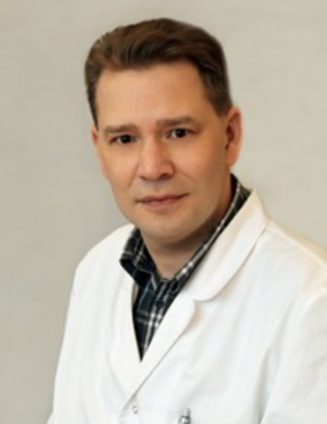  Research supervisor:  Petr A. Kochetkov,  Doctor of Science (Sechenov University) | TD OTORHINOLARYNGOLOGY
Supervisor’s research interests
Sinonasal surgery

Supervisor’s specific requirements:
Раздел заполняется при наличии требований, предъявляемых к аспиранту (обязательный бэкграунд кандидата/дисциплины, которые он обязательно должен был освоить/ методы, которыми он должен владеть/ уметь пользоваться каким-то определённым ПО и др.)
- _Specialization on otorhinolaryngology_________________________________________
- __________________________________________
Supervisor’s main publications 5:
- Grusha YO, Kochetkov PA, Danilov SS, Duvanova ED, Sviridenko NYu. Complications of transnasal endoscopic orbital decompression in thyroid eye disease. Vestnik Oftalmologii. 2023;139(3):63‑68. (In Russ.)
- https://doi.org/10.17116/oftalma202313903163
- Svistushkin MV, Kotova S, Shpichka A, Starostina S, Shekhter A, Bikmulina P, Nikiforova A, Zolotova A, Royuk V, Kochetkov PA, Timashev S, Fomin V, Vosough M, Svistushkin V, Timashev P. Stem cell therapy for vocal fold regeneration after scarring: a review of experimental approaches. Stem Cell Res Ther. 2022 May 3;13(1):176. doi: 10.1186/s13287-022-02853-9. PMID: 35505357; PMCID: PMC9066721.
- Grusha, Y.O., Kochetkov, P.A., Ismailova, D.S., ...Zhorzholadze, N.V., Spychak, V.Y. Efficacy of transethmoidal orbital decompression in patients with dysthyroid optic neuropathy. Vestnik Otorinolaringologii 2020, 85(6), 52–55 10.17116/otorino20208506152
- Grusha Y.O., Ismailova, D.S., Kochetkov, P.A., Andreeva, N.A. Dysthyroid optic neuropathy: Surgical treatment potential. Vestnik Oftalmologii. 2020, 136(4),193–200 10.17116/oftalma2020136042193
- Kochetkov P.A. Transethmoidal decompressive orbitotomy in the patients presenting with endocrine ophthalmopathy at the stage of remission: peculiarities of the surgical intervention and the results of exophthalmos correction. Vestnik Otorinolaringologii. 2017, 82(1), стр. 38–42. 10.17116/otorino201782138-42
- Kochetkov, P.A., Svistushkin, V.M., Mokoyan, Z.T., Karpova, O.Y., Ordyan, A.B. Extended trans-ethmoidal decompression of the orbit for the treatment of frontal sinus mucopyocele Vestnik Otorinolaringologii. 2018, 83(6), стр. 55–57. 10.17116/otorino20188306155
Results of intellectual activity (при наличии)
(Наиболее значимые результаты интеллектуальной деятельности)

